**6MMCS002**

**Digital Marketing, Social Media and Web Analytics**

**Vassiliki Bouki**

**Tutorial 3:** Implementing a Website using ‘Google Sites’

For the needs of the coursework you have to implement a website. You’ll use this website in order to apply Search Engine Optimization techniques as well as ‘Google Analytics’ tools. During this tutorial you will gain hands-on experience to work with ‘Google Sites’ - an easy to use and intuitive Web-based interface to design and maintain websites. You will be able to create your website without any knowledge of HTML or programming.

The following steps explain how you can create a website using ‘google sites’. For beginners it is recommended to follow these steps in the specific order they are introduced. After completing the task, you can continue experimenting with Google Sites and customising the website according to your requirements. As a student of the University of Westminster you can create websites using Google Sites that are either **private or public.**

**PLEASE NOTICE** the current version of ‘Google Sites’ is ‘New Google Sites’. The previous version was ‘Google Classic Sites’. **‘Classic sites’** option is not available any more for new sites.

|  |
| --- |
| **Step 1** Login to the University of Westminster intranet using your account, select Google Mail and apps and log in. |
|  |



|  |  |
| --- | --- |
| **Step 2**  Select **‘Sites’** on the top of the screen (It is under 'Apps'). The page will look like that:  ***As I do not have access to a student Google account, this might look a bit different. Still you search for ‘Sites’.*** | ../../../../../../Desktop/Screen%20Shot%202021-01-23%20at%20 |

|  |
| --- |
| **Step 3**  You will be transferred to a page that looks like the following: |
| ../../../../../../Desktop/Screen%20Shot%202021-01-23%20at%20 |

The above is the layout of “New Sites”.

It is the ONLY option that is offered **for new users.**

**Step 4**

From here you can create a new site and access existing sites. Please notice that if in the past you used ‘Classic Google Sites’, you also get the option: “Back to Classic Sites”. Click on the “+” symbol to start a new site

**Step 5**

|  |  |
| --- | --- |
| In the new screen please notice the if you click ‘More’ on top, you get a tour of the layout. | ../../../../../../Desktop/Screen%20Shot%202022-01-21%20at%20 |

**STEP 6:**

|  |  |
| --- | --- |
| Now you can fill your pages with content. Explore the section insert on right.  There are tens of options, including images, videos, map etc.  Practice with these:  a) insert a picture  b) insert text  c) insert a list  d) insert a link to an external page (any)  e) insert a map  anything else you like | ../../../../../../Desktop/Screen%20Shot%202022-01-21%20at%20 |

**STEP 7:** You can further refine the layout of any of your pages. Try different layouts and customise your pages accordingly.

**STEP 8:**

|  |  |
| --- | --- |
| Try the next option on the right: Pages  Click on the “+” symbol at the bottom and see the options.  Extend your Website with more pages. | ../../../../../../Desktop/Screen%20Shot%202022-01-21%20at%20 |

**STEP 9:** Try the ‘New menu actions’ and the ‘New link”

**STEP 10:** Explore the last option: “Themes”

**STEP 11: VERY IMPORTANT: Publish your site**

Click on ‘Publish’ option on the right. You get the following screen:

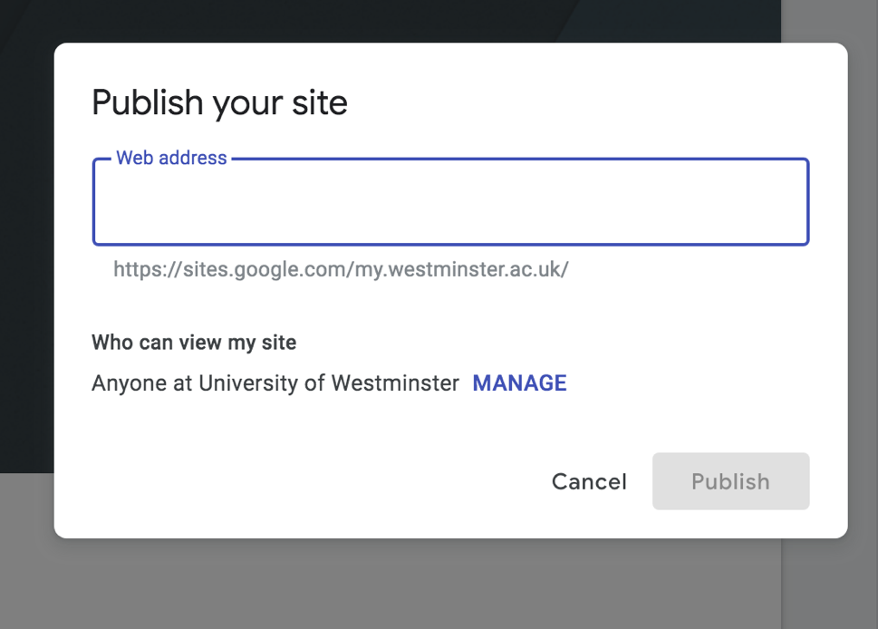

Here you should decide the name of your site (you’ll need it for optimization’. Furthermore, click on ‘Manage’ to see you options. Click ‘Links’ 🡪 Change, to make your site available on the internet.

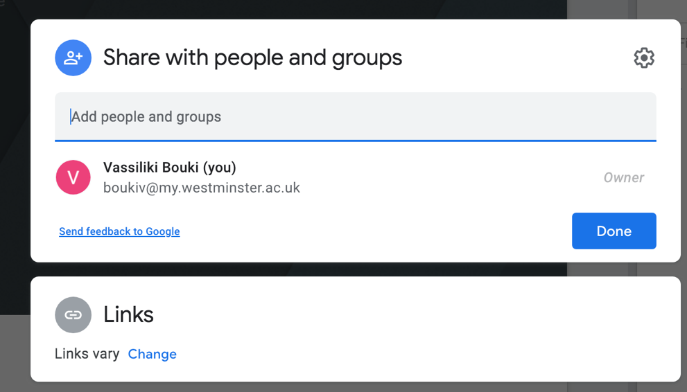

Your site is NOT by default available on the internet. If you want to optimize it and to collect information with Google Analytics you MUST make it available – this is a very common mistake that students do and forget to make the site available on the internet.

**STEP 12:** Furthermore, explore the settings:

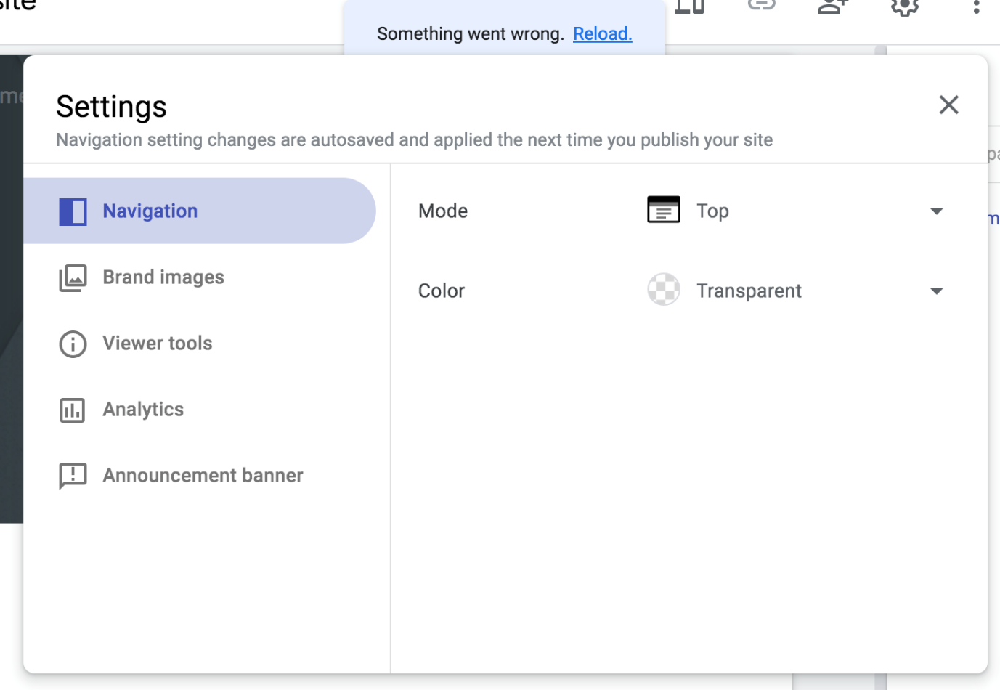

Notice here, the option: **Analytics**.

**STEP 13:** Spend some time to explore more options.

**STEP 14:** If Click the preview on top:  to preview your site in different devices.

**ATTENTION**

The aim of this tutorial is to navigate you through the main options you have in ‘**Google Sites’.** Practice further and explore your options. Start creating your own website according to coursework description.

Watch the following youtube video for google sites (for beginners) and do your own research for further tutorials: <https://www.youtube.com/watch?v=lAwEP9ljsIU>